Lista de livrarias e lojas nas quais seu livro foi cadastrado e pode ser adquirido

https://www.pontofrio.com.br/
https://www.extra.com.br/
https://www.martinsfontespaulista.com.br/
https://www.travessa.com.br/
https://www.submarino.com.br/
https://www.shoptime.com.br/
https://www.americanas.com.br/
https://www.magazineluiza.com.br/
https://www.casasbahia.com.br/
https://www.livrariaflorence.com.br/
https://www.livrariascuritiba.com.br/

https://www.livrarialoyola.com.br/
https://www.editoraufv.com.br/marca/appris-editora
https://leitura.com.br/index.php?route=common/home
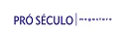
https://www.proseculo.com.br/
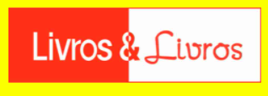
https://www.livroselivros.com.br/
https://www.amazon.com.br/
https://www.amazon.de/ref=nav_logo
https://www.amazon.com/-/es/ref=nav_logo
https://www.amazon.co.uk/ref=nav_logo
https://www.amazon.es/ref=nav_logo
https://www.amazon.com.mx/ref=nav_logo
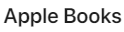
https://www.apple.com/apple-books/
https://www.barnesandnoble.com/
https://www.bol.de/
https://www.buecher.de/
https://www.casadellibro.com/
https://www.ebook.de/de/

https://www.elcorteingles.es/
https://play.google.com/store?gl=br
https://www.hugendubel.de/de/
https://www.kobo.com/br/pt
https://www3.livrariacultura.com.br/
https://www.orellfuessli.ch/
https://www.osiander.de/index.cfm
https://pt.scribd.com/
https://www.storytel.com/br/pt/
https://www.tagusbooks.com/
https://www.thalia.de/

https://www.weltbild.de/
https://www.wook.pt/

